WEBSITE AUDIT

Client Name: CHEMIECOMM (Chemistry to Commerce)
Website URL: https://chemiecomm.com/
Audit Date: 17th Nov 2025

- Dashboard Issue:
  - Username repeated. Only one time username should be mentioned. With a logout option.
  - Only vendor dashboard option visible.
Add customer dashboard option also if the user applied for both options.
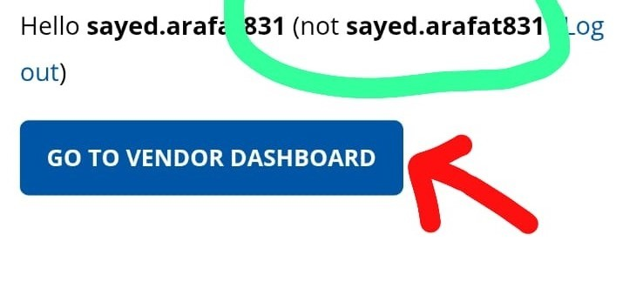

- No social media platforms working.
At least make an account on all and just link that account only. Essentials Links
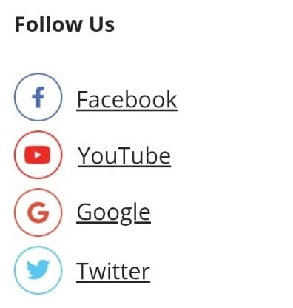

- Company Updation Issue:
Product detail updated but still product not showing anywhere. Its still showing pending.
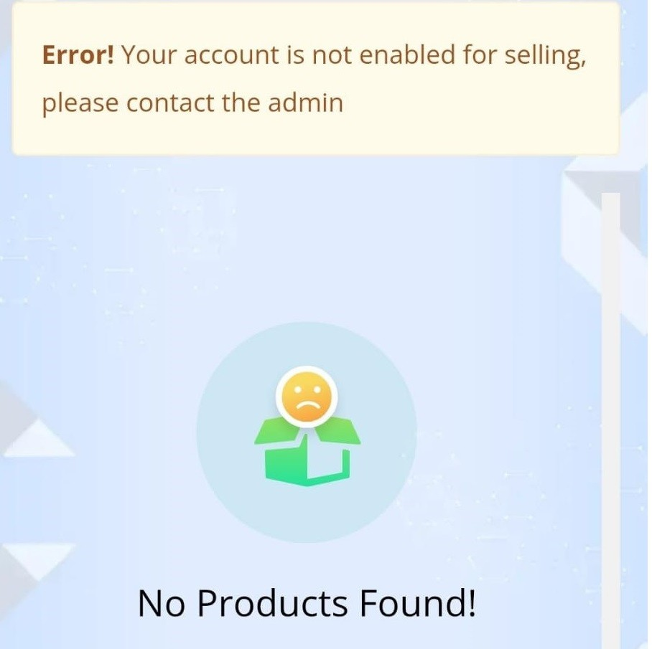

- Vendor dashboard:
When clicking settings, it should not go to the next page. Only the drop-down menu should come.
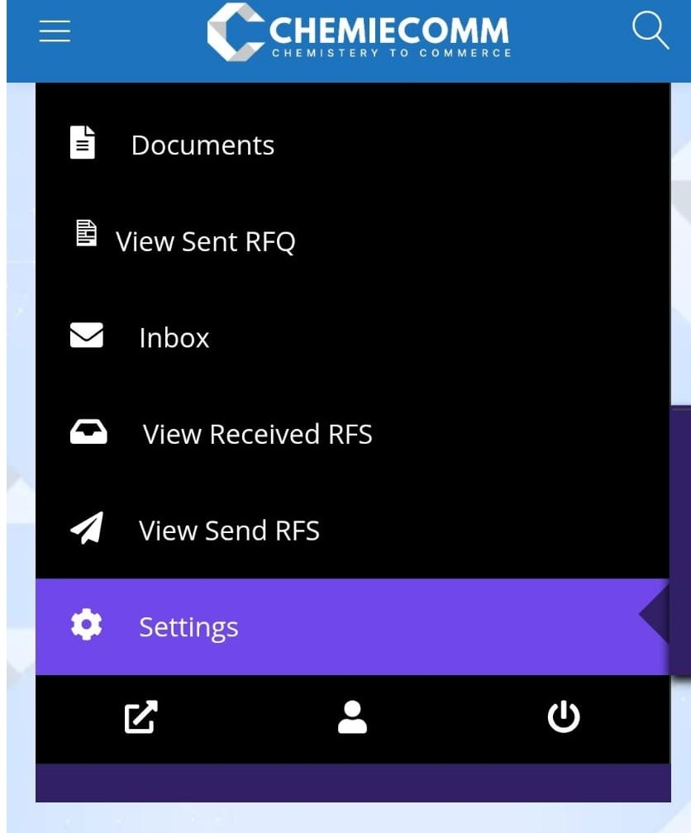

- Payment Update by Vendor
Payment Method option is not showing in vendor dashboard and an error is showing while clicking the link Add a payment method.
Payment method is not showing while updating the product.

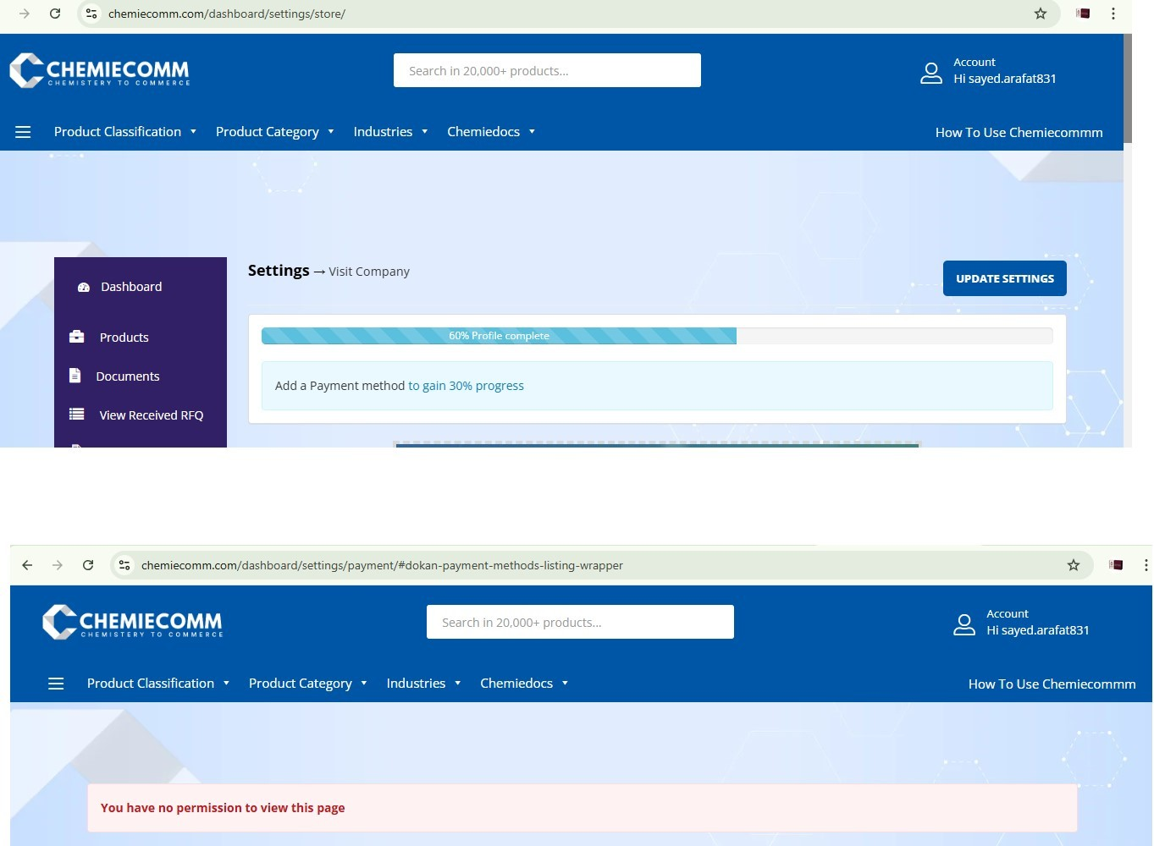

- In url link: https://chemiecomm.com/document/, View Documents link not working.
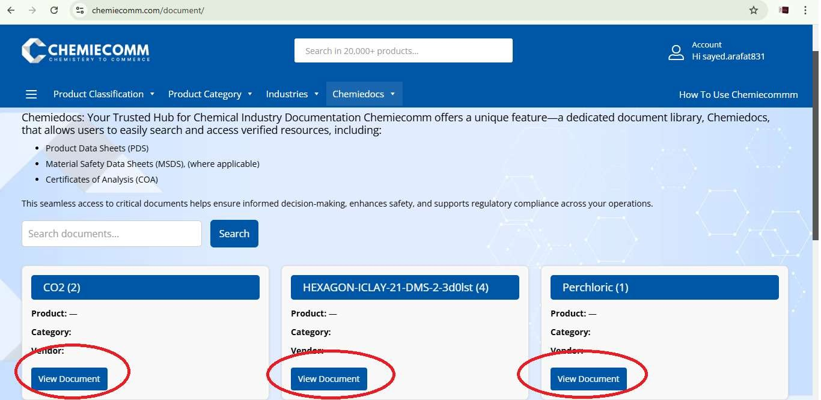

- All options to update profile should come in one pages. Right now its showing one by one.

- Links in the Header Menu/submenus have no descriptions.

- Website performance:

Mobile

Desktop

Speed Index:

s
9.2

s
2.8

Website Performance

56/100

77/100

Accessibility

70/100

74/100

SEO

69/100

69/100

Note:
The website is taking more time to open in mobile
.

- Website should be monitored, maintained, and troubleshoot for the site's performance in Google Search. Also, pages to be indexed to appear in search engines.

NOTE:
- Other testing can be done once all products are approved with all required updated details of the vendor/customer registration.
- Website Optimization required.

Other detailed testing results:

1. Current Status Check
- The domain chemiecomm.com does not resolve to a working website as there is no publicly visible web app or pages when trying to load it.
- There’s a LinkedIn profile only with titled “ChemieComm – Simplifying B2B Chemical Trade”, which suggests the company or service exists, but the website in google is not correctly deployed.
- Search engine found no credible screenshots, archived pages, or working versions in the public web cache.
Conclusion: As of now, there’s no live, accessible website at that domain (or it's misconfigured).
2. Potential Risks / Likely Bugs
Here are specific risks / likely bugs that the Chemiecomm.com site may face, plus what to watch out for: 1. User authentication/on-boarding issues:
- Buyer vs seller registration confusion. o Poor validation in registration form (invalid company names, GST / tax ID, address).
- Incomplete profile flows.
- RFQ or quote request flow:
  - RFQ form not collecting enough data (e.g., CAS number, purity, quantity). o No error handling for invalid inputs (special characters, decimal quantities).
  - Missing file upload validation (if users attach specification sheets).
- Product/catalogue issues:
  - Catalogue listing missing critical info (chemical name, CAS, packaging, purity). o Pagination or filtering bugs (e.g., filtering by quantity or region doesn’t work).
  - Missing or broken images/documents for chemicals.
- Performance problems:
  - Slow page load for catalogue or search results.
  - Timeouts in RFQ submission under load. o Large pdf/spec sheet download is slow.
- Security vulnerabilities:
  - Unsecured form endpoints (lack of CSRF tokens).
  - XSS in RFQ or message fields.
  - Weak session management (session never expires, or cookie is not secure).
- Usability / UX Issues:
  - Confusing navigation (how to switch between buyer and supplier dashboards).
  - Missing or unclear CTA (Call to Action): request quote, list a product, join as supplier.
  - Not mobile-friendly, especially for RFQ forms.
- Accessibility:
  - No alt text on product images. o Poor colour contrast.
  - Keyboard users cannot tab through the form properly.
- Error handling:
  - Unfriendly error messages (e.g., “Internal Server Error” rather than “Could not submit, please try again”).
  - No proper confirmation / thank-you page after RFQ submission.
- SEO / Metadata:
  - Missing meta-title / description for key pages. o No Open Graph / social-meta tags.
(Note: this is not for whole SEO process. It is only to show on Google. The raking depends on the SEO techniques).

3. Recommendations
- First, make sure the domain is correctly configured (DNS, hosting).
- Deploy a staging environment and run all the above tests before going live.
- Engage real users (chemicals industry people) for usability testing.
- Prioritize bug fixes by severity: security > functional > usability.
- Set up monitoring for uptime, error logs, and performance metrics.
- Maintain documentation: test cases, bug report logs, and regression checklist.

5-1-26 issues discussed.

- Payment method remove.
- Email check whether it is working or not
- Titles on hover over navbar menu
- Upload documents in each navbar menu sections and test the search functionality.
- Chemidocs documents

